ISEC QUESTIONS

Q.1 What is the occupation of the person who contributes the most to the running of your household?
If Retired/Unemployed ask: What was his/her occupation before he retired/was out of work?

Occupation URBAN
Unskilled Worker | 1
Skilled Worker | 2
Petty Traders | 3
Shop Owners | 4
Businessman/Industrialist (No Employees) | 5
Businessman/Industrialist (1 – 9 Employees) | 6
Businessman/Industrialist (10+ Employees) | 7
Self Employed Professional | 8
Clerk / Salesman | 9
Supervisory Level | 10
Officer / Executive – Junior | 11
Officer / Executive – Middle /Senior | 12
Owner Farmer | 13
Leased Farmer | 14
Not Applicable | 99

Occupation RURAL
Owner Farmer | 1
Leased Farmer | 2
Agricultural Worker | 3
Owner Of Livestock | 4
Owner Of Fisheries | 5
Owner Of Poultry | 6
Unskilled Labourer (Other Than Agriculture) | 7
Artisan / Skilled Labourer | 8
Trader / Shopkeeper | 9
Postman | 10
Teacher | 11
Doctor | 12
Service (Rural In any village) & CWE Education illiterate to 9th standard | 13.1
Service (Rural In any village) & CWE Education 10 to Graduate | 13.2
Service (Rural In any village) & CWE Education Grad/Post Grad Prof or Post Grad General | 13.3
Service (Urban) & CWE Education illiterate to 9th standard | 14.1
Service (Urban) & CWE Education 10 to Graduate | 14.2
Service (Urban) & CWE Education Grad/Post Grad Prof or Post Grad General | 14.3
Petty Traders | 15
Shop Owners | 16
Businessman/Industrialist (No Employees) | 17
Businessman/Industrialist (1 - 9 Employees) | 18
Businessman/Industrialist (10+ Employees) | 19
Self Employed Professional | 20
Clerk / Salesman | 21
Supervisory Level | 22
Officer / Executive – Junior | 23
Officer / Executive – Middle /Senior | 24
Not Applicable | 99

ISEC OCCUPATION CLASSIFICATION
ISEC | Class | Urban | Rural
1 | Labour | 1 | 3,7,
2 | Farmer | 13,14 | 1,2,4,5,6
3 | Worker | 2 | 8,10,13.1,14.1
4 | Trader | 3,4,5,6 | 9,15,16,17,18
5 | Clerical/Sales/Supervisory | 9, 10 | 11,13.2,14.2,21,22
6 | Managerial/professional | 7,8,11,12 | 12,13.3,14.3,19,20,23,24

Instruction: Detailed definition of each occupation

1. Labour: It is defined as someone who has not learned or been taught any specialized skills to
do a particular job that earns him a salary or wage. Anyone who is just employed to do any set of activities which do not require any specific skills other than being of sane mind and physically fit body.

2. Farmer: Farmer is one who earns by owning, leasing or being a sharecropper in farms. Anyone who earns by owning a business in or of poultry, fishery, dairy, livestock (cattle including goats & sheep, horses and camels).

3. Worker: One who is EMPLOYED by someone else and IS NOT SELF EMPLOYED. He/she has been taught a specific skill to do a job for which he/she is paid or earns a wage. These are higher order skills unlike being taught to fold letters and inserting in an envelope, fold pieces of cardboard to make boxes or arrange glasses filled with water on a tray and serve to customers in a restaurant. Everyone has to be imparted skills required for doing any of these jobs.

4. Trader/Shopkeeper: One who OWNS or runs a SMALL business from either a pucca or a mobile vending cart (thela) or operates. The difference between a Trader/Shopkeeper and a Worker is that the Trader/Shopkeeper OWN HIS BUSINESS (say a Salon or hair cutting Saloon) where the worker is EMPLOYED and is PAID A WAGE for the work he does in a day/week or month (may be in a similar business…like a barber)

5. Clerical/sales/supervisory: One who is PAID a salary and is EMPLOYED by a Company, an Organization, an establishment or a Government Department. He is NOT EMPLOYED by an individual. These EMPLOYEES are Junior and Middle-level employees who are in a job that requires instructions and/ or orders from above to do their duties/fulfill their jobs

6. Executive or self-employed professionals: These are people who are in Managerial or Decision-Making roles in a Department, Organization, or Establishment or are self-employed like Doctors, Lawyers, singers, musicians, or Artists
Q.2 Among men above 21 years of age, who live in this household, what is the highest that anyone has studied? If no male adult over 21, ask for males in ‘18 to 20 years’ age group. If no male adult over 18, record, and skip to next question

No male adult | 1
No formal education | 2
Upto Class 5 standard | 3
Class 6 – 9th standard | 4
Class 10 -14 standard | 5
Degree Regular (e.g. B.A., B.Sc., B.Com., M.A., M.Sc., M.Com, BBA, BCA) | 6
Degree Professional (e.g. B.E., B.Tech., MTech., C.A., M.B.B.S., L.L.B., MBA, MCA, MD, PhD) | 7

Q.3 Among women above 21 years of age, who live in this household, what is the highest that anyone has studied? If no female adult over 21, ask for females in ‘18 to 20 years’ age group. If no female adult over 18, record, and skip to next question

No female adult | 1
No formal education | 2
Upto Class 5 standard | 3
Class 6 – 9th standard | 4
Class 10 -14 standard | 5
Degree Regular (e.g. B.A., B.Sc., B.Com., M.A., M.Sc., M.Com, BBA, BCA) | 6
Degree Professional (e.g. B.E., B.Tech., MTech., C.A., M.B.B.S., L.L.B., MBA, MCA, MD, PhD) | 7

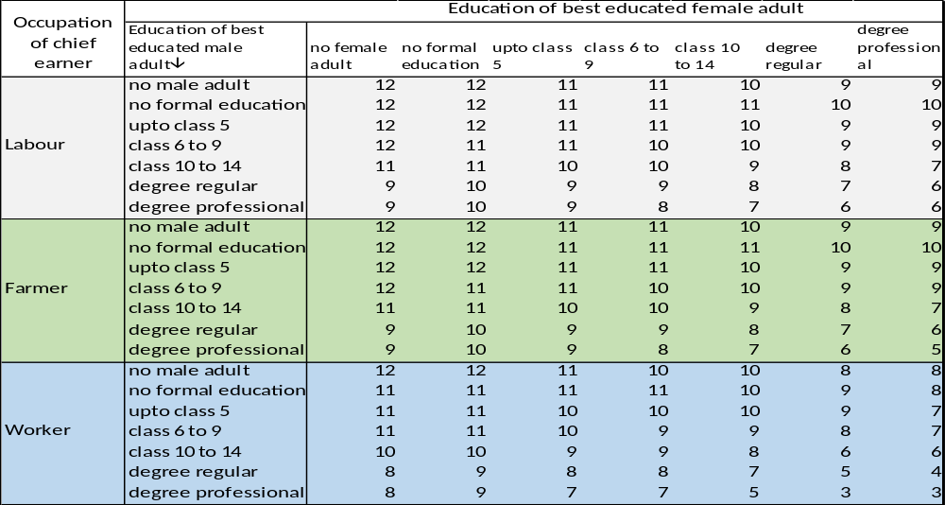

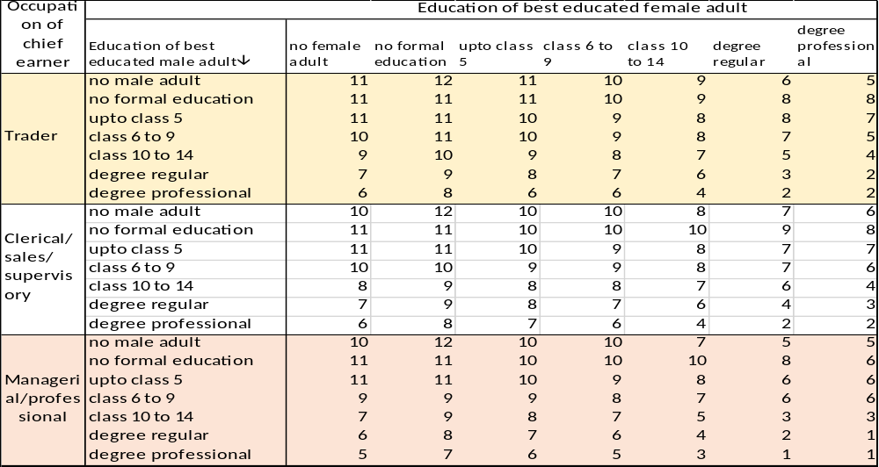

ISEC | Class
G1-G6 | High / Upper
G7-G8 | Upper Middle
G9-G10 | Middle
G11 | Lower Middle
G12 | Lower

